Responsibility To Others Pt. 2 sermon for 4-30-17

Responsibility to Bear Others’ Burdens

Galatians 6:1-5 (NKJV)
6 Brethren, if a man is overtaken in any trespass, you who are spiritual restore such a one in a spirit of gentleness, considering yourself lest you also be tempted. 2 Bear one another’s burdens, and so fulfill the law of Christ. 3 For if anyone thinks himself to be something, when he is nothing, he deceives himself. 4 But let each one examine his own work, and then he will have rejoicing in himself alone, and not in another. 5 For each one shall bear his own load.

Restore the Dislocated

“Overtaken” = to take one by forestalling him before he can flee or conceal his crime, to surprise or detect

“Overtaken” in Gal 6:1 means that someone is taken by surprise by a moral fault that God would not allow to stay hidden as though God stalled the person who was morally wrong so that their sin would be found out by others.

God will often lovingly ambush us into being caught red-handed in our sins because we are blind to our own sin.

Even when sin is unintentional and hidden, it can wreak havoc on people’s lives.

What are we supposed to do when we see a fallen brother or sister unintentionally sinning?

Restore them.

Don’t you like that word? Say out loud…restore.

You know why you like it? Because it’s the word of mercy and grace. It’s what Jesus did for you when you believed in Him as your savior.

Restoring a fallen brother or sister is to adjust them into proper working order where they can fulfill God’s will for their lives.
- The same word is used for “mending” in

Mark 1:19 (NKJV)
19 When He had gone a little farther from there, He saw James the son of Zebedee, and John his brother, who also were in the boat mending their nets.
- Mending the nets allowed them to be used for their original purpose.
- The same word was used in ancient times for a joint that was dislocated or “out of joint”.
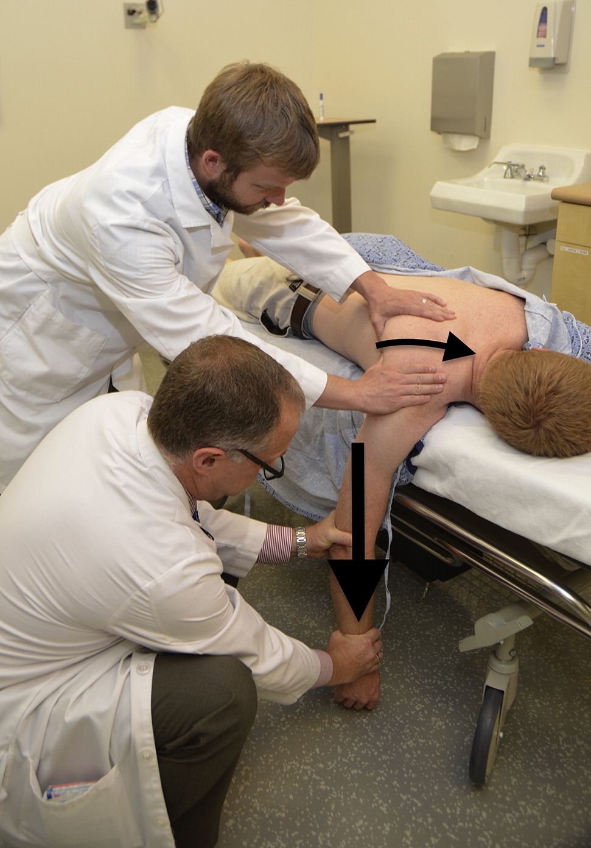
A member of Christ’s body can be dislocated by sin, but those who are spiritual can gently relocate the out of place member.
Remember, we are talking about a particular person here. Someone who is truly blind to their sin—someone confused. Not someone who with all wherewithal knows that they are choosing a dark path and will not repent.
Gently doesn’t mean that there is no pain involved to Christ’s body though…restoring a dislocated member requires correction.

Bear the Burden of Correction

This is the answer to the question “How does one restore a person in fault?”
The answer is to correct them lovingly and humbly.

Lovingly
This form of the word “bear” in Gal 6:2 means to endure the weight of something troublesome;

Correction should never be relished or avoided when necessary.

1 Corinthians 13:6 (NKJV)
6 does not rejoice in iniquity, but rejoices in the truth;

Correction is a burden. It would be easier to look the other way or to cover up the fault.

Biblical correction is a gentle, understanding, yet truthful procedure where the one correcting does so while coming beside the fallen friend and helping them carry their troublesome and usually unexpected burden.

It means that the one correcting should ask questions, listen to the negative emotions of the one in sin, sympathize with their struggle, pray for them, and never look down on the person. It’s talking about the attitude of the corrector.

It does not mean that the one correcting should take over any decisions or responsibilities that belong to the one in fault.

Humbly
3 For if anyone thinks himself to be something, when he is nothing, he deceives himself.

When our perspective is accurate, then our behaviors are restrained and balanced; when our perspective is distorted, then our behaviors become unrestrained and out of balance.

Pride will distort your perspective leading you to redefine the facts of a situation to fit your self-deception.

We must humble ourselves so that our perspective of the facts is not warped by our false estimation of ourselves and our behavior toward the one to be corrected is restrained and balanced.

One word of caution: not everybody should correct everybody. You must know your place, your level of maturity, the appropriate time and place for any correction, and your instructions from God.

Take Responsibility for Your Load

4 But let each one examine his own work, and then he will have rejoicing in himself alone, and not in another. 5 For each one shall bear his own load.

Verses 4 and 5 tell us clearly that we are to “examine our own work” and “bear our own load”.

Before you correct anyone, examine your own work to see if it’s genuine or not.
Do you know what your work is? Does your work include correcting the faulty brother?

Are you doing the best that you can to be diligent about God’s work for you or are you meddling into someone else’s work because you are not able or willing to take care of your own responsibility?

This word “bear” means something different than the word “bear” in the 2nd verse.
Whenever we try to force or manipulate others to bear our personal loads assigned to us by God, grievous and often long-term consequences come.

Bear in verse 2 means to endure something troublesome; whereas “bear” in verse 5 is phortion and means the burden which must be carried by an individual.

It suggests the image of a ship loaded with cargo.

All of us have individual burdens in life to bear that cannot be transferred to others, and others have no right to take them off us.

God has given you precious cargo for only you to carry throughout life.

Whenever we try to force or manipulate others to bear our personal loads assigned to us by God, grievous and often long-term consequences come.

What is our load? (from Boundaries by Dr.’s Henry Cloud and John Townsend)
- Feelings
  - Feelings shouldn’t be ignored or put in charge.
- Attitudes and Beliefs
  - “Attitudes have to do with your orientation towards something, the stance you take toward others, God, life, work, and relationships. Beliefs are anything that you accept as true.”
- Behaviors
  - Behaviors have natural consequences; it’s the law of reaping and sowing.
- Choices
  - Taking responsibility for our choices leads to self-control.
- Values
  - We have the ability to admit to misplaced or wicked values if we are willing to admit that we love and desire wicked things. We take responsibility to own these bad values not so we can keep them, but so God can change them.
- Limits
  - Outer limits
    - Separating ourselves from people who are acting in destructive ways. Saying “no” to others.
  - Inner limits
    - “We need to be able to say no to ourselves.” We must be able to admit to ourselves wrong feelings, thoughts, or desires without giving in to them.
- Talents
  - Ownership and use of talents is often frightening and always risky. It takes a lot of prayer, practice, learning, resources, and grace to overcome fear of failure.
- Thoughts
  - We must own our own thoughts.
  - We must grow in knowledge and expand our minds.
  - We must clarify distorted thinking.
- Desires
  - To know what to ask God for, we must do the work of getting to know who we really are and identifying our real motives.
- Love
  - There must be a receiving of love and a giving of love.
  - You must take ownership of for how we receive or reject the love around us.

These ten burdens we are to carry are largely internal.

Our internal loads are for us to bear, but most of our external loads are meant to be shared to an extent with community.

